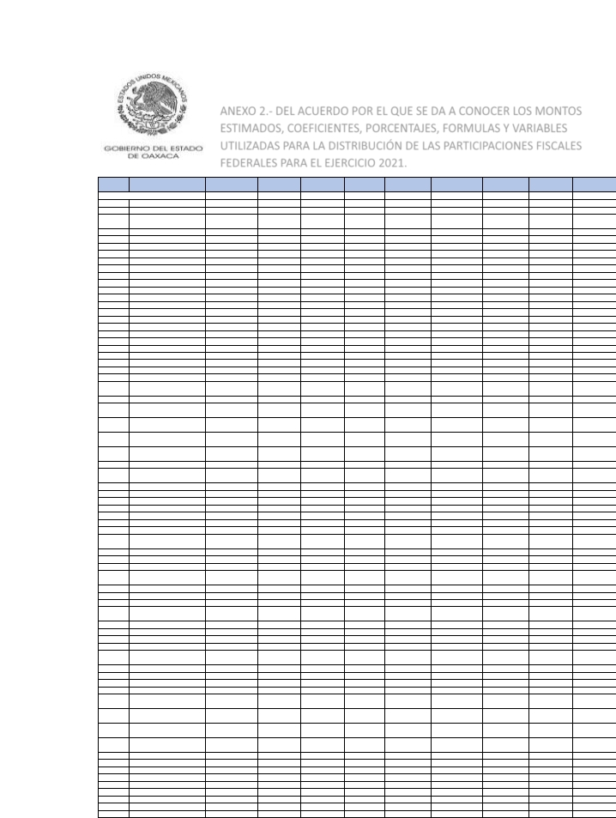ANEXO 2.- DEL ACUERDO POR EL QUE SE DA A CONOCER LOS MONTOS
ESTIMADOS, COEFICIENTES, PORCENTAJES, FORMULAS Y VARIABLES
UTILIZADAS PARA LA DISTRIBUCIÓN DE LAS PARTICIPACIONES FISCALES
FEDERALES PARA EL EJERCICIO 2021.

Clave
municipio

1
2
3
4
5
6
7
8
9
10
11
12
13
14
15
16
17
18
19
20
21
22
23
24
25
26
27
28
29
30
31
32
33
34
35
36
37
38
39
40
41
42
43
44
45
46
47
48
49
50
51
52
53
54
55
56
57
58
59
60
61
62
63
64
65
66
67
68
69
Nombre del municipio

ABEJONES
ACATLÁNDE PÉREZ FIGUEROA
ASUNCIÓNCACALOTEPEC
ASUNCIÓNCUYOTEPEJI
ASUNCIÓNIXTALTEPEC
ASUNCIÓNNOCHIXTLÁN
ASUNCIÓNOCOTLÁN
ASUNCIÓNTLACOLULITA
AYOTZINTEPEC
EL BARRIODELASOLEDAD
CALIHUALÁ
CANDELARIALOXICHA
CIÉNEGADE ZIMATLÁN
CIUDADIXTEPEC
COATECASALTAS
COICOYÁNDE LASFLORES
LACOMPAÑÍA
CONCEPCIÓNBUENAVISTA
CONCEPCIÓNPÁPALO
CONSTANCIADEL ROSARIO
COSOLAPA
COSOLTEPEC
CUILÁPAMDE GUERRERO
CUYAMECALCOVILLADE
ZARAGOZA
CHAHUITES
CHALCATONGODE HIDALGO
CHIQUIHUITLÁNDE BENITO
JUÁREZ
HEROICACIUDADDEEJUTLA
DE CRESPO
ELOXOCHITLÁNDE FLORES
MAGÓN
EL ESPINAL
TAMAZULÁPAMDELESPÍRITU
SANTO
FRESNILLODE TRUJANO
GUADALUPE ETLA
GUADALUPE DE RAMÍREZ
GUELATAODE JUÁREZ
GUEVEADE HUMBOLDT
MESONESHIDALGO
VILLAHIDALGO
HEROICACIUDADDE
HUAJUAPANDELEÓN
HUAUTEPEC
HUAUTLADE JIMÉNEZ
IXTLÁNDE JUÁREZ
HEROICACIUDADDE JUCHITÁN
DE ZARAGOZA
LOMABONITA
MAGDALENAAPASCO
MAGDALENAJALTEPEC
SANTAMAGDALENAJICOTLÁN
MAGDALENAMIXTEPEC
MAGDALENAOCOTLÁN
MAGDALENAPEÑASCO
MAGDALENATEITIPAC
MAGDALENATEQUISISTLÁN
MAGDALENATLACOTEPEC
MAGDALENAZAHUATLÁN
MARISCALADE JUÁREZ
MÁRTIRESDE TACUBAYA
MATÍASROMERO AVENDAÑO
MAZATLÁNVILLADE FLORES
MIAHUATLÁNDEPORFIRIO
DÍAZ
MIXISTLÁNDE LAREFORMA
MONJAS
NATIVIDAD
NAZARENOETLA
NEJAPADE MADERO
IXPANTEPECNIEVES
SANTIAGONILTEPEC
OAXACADE JUÁREZ
OCOTLÁNDEMORELOS
LAPE
FGP 2021
Monto
3,700,754,530
1,443,995
27,227,030
1,919,866
1,050,774
20,836,876
17,857,296
2,764,484
1,444,067
4,287,899
14,093,505
1,290,947
6,192,730
4,252,082
31,855,734
3,495,061
5,440,496
2,611,801
1,187,247
2,286,707
3,135,836
9,570,903
1,408,193
11,533,929
4,489,178
9,255,081
6,510,581
2,184,765
13,672,962
3,471,239
16,857,231
7,042,927
1,333,318
2,023,049
1,485,175
685,060
3,696,672
3,053,271
1,732,883
93,893,644
3,835,534
20,021,865
7,587,026
77,266,499
40,132,646
5,124,796
3,864,120
640,157
1,535,988
1,254,287
2,914,758
3,424,610
5,084,243
3,989,507
975,462
5,448,680
1,345,130
36,376,167
8,035,940
32,692,366
2,251,876
3,122,386
930,690
2,082,793
4,977,779
1,561,758
5,385,499
400,698,393
18,516,414
2,062,858
FIEPS 2021
Monto
44,619,165
23,668
341,707
28,553
15,766
230,477
186,888
40,935
19,842
53,205
154,249
20,095
79,411
55,251
362,731
49,488
71,554
37,212
19,158
32,944
41,516
122,569
18,731
125,415
54,134
85,625
86,024
32,253
175,267
46,912
152,682
76,037
20,912
26,003
21,206
10,302
47,256
42,510
24,635
966,307
52,143
271,682
88,651
933,332
476,978
55,556
47,026
10,815
23,801
19,544
39,385
46,627
49,206
68,364
14,539
60,101
20,410
392,900
106,851
391,560
30,607
41,749
14,918
26,939
63,795
23,728
63,136
5,163,506
218,763
30,065
FISAN 2021
Monto
15,619,788
6,403
116,800
8,393
4,601
88,611
74,951
12,077
6,258
18,307
60,469
5,682
26,699
18,271
138,296
15,210
23,506
11,366
5,281
9,967
13,543
41,427
6,100
48,871
18,748
38,894
28,232
9,569
58,995
14,936
67,496
29,017
5,879
8,843
6,448
3,013
15,821
13,261
7,524
395,446
16,609
86,575
32,389
327,294
170,394
21,683
16,506
2,872
6,756
5,528
12,566
14,835
21,482
17,839
4,270
23,435
5,910
152,646
34,704
136,585
9,679
13,403
4,102
8,991
21,382
6,843
23,096
1,514,020
79,392
9,014
FOCOISAN 2021
Monto
6,967,646
4,182
54,841
4,949
3,037
27,951
27,847
7,101
3,013
9,511
17,248
3,467
12,343
9,754
66,855
8,257
11,371
6,274
3,488
5,572
6,546
19,960
3,207
16,543
8,878
12,443
13,091
5,407
26,625
7,759
22,319
12,403
3,646
4,454
3,577
1,972
7,572
7,126
4,217
146,476
8,591
44,799
13,756
147,163
73,763
7,550
8,484
1,927
4,096
3,382
6,876
7,575
9,641
11,884
2,590
6,137
3,511
59,248
17,518
59,154
5,235
6,682
2,737
4,778
10,824
4,133
11,889
856,419
32,365
5,032
FOFIR 2021
Monto
179,916,011
78,936
1,348,163
100,709
54,742
1,016,362
827,807
144,806
74,505
207,828
698,793
69,239
311,491
210,530
1,508,644
180,936
275,523
135,144
64,749
118,961
159,042
482,612
71,190
552,675
209,696
406,798
333,402
115,180
690,154
174,598
696,900
314,476
71,618
103,286
76,561
35,897
182,873
156,917
89,228
4,362,413
195,548
1,017,679
368,713
3,718,771
1,937,410
244,245
186,650
35,978
82,212
67,286
146,405
175,055
217,409
223,808
51,084
273,135
71,445
1,690,527
406,181
1,568,790
112,852
156,728
49,948
103,853
246,708
82,528
248,839
18,862,187
912,422
108,064
FFM 2021
Monto
1,365,134,663
637,699
10,159,806
594,787
449,585
4,777,294
6,408,557
1,184,014
647,119
2,004,271
4,012,460
474,883
1,836,633
2,212,908
9,273,462
1,560,272
892,286
596,177
573,829
571,543
2,278,277
4,062,008
580,920
4,966,096
2,532,156
3,504,970
1,865,039
1,505,596
4,249,313
2,363,068
2,101,016
1,135,903
769,343
772,111
781,323
644,584
813,042
670,418
811,789
30,923,381
780,082
8,039,232
1,719,844
28,409,339
20,212,505
3,056,353
1,506,742
369,385
679,332
687,696
930,808
1,352,425
2,200,171
2,191,640
522,173
1,652,904
471,866
12,860,942
1,181,201
13,843,678
810,199
1,237,398
488,229
406,517
1,669,737
992,126
3,902,196
174,436,468
7,653,977
628,678
FOCO2021
Monto
107,014,958
25,945
1,257,393
58,682
24,208
378,733
479,787
78,196
19,657
195,361
346,723
34,719
331,191
76,264
674,617
150,317
345,781
98,509
22,638
84,628
120,088
421,648
19,235
539,860
110,719
294,874
250,771
69,377
578,693
130,982
196,091
204,771
29,369
63,746
32,198
12,460
154,556
132,414
55,994
1,905,885
217,407
982,135
215,218
2,423,518
1,103,305
197,115
90,245
2,163
42,393
31,243
106,176
150,561
160,019
31,794
10,869
93,697
40,352
1,085,597
413,403
1,127,002
76,866
79,990
11,783
92,654
205,260
36,148
142,120
5,902,348
576,938
79,612
FOGADI2021
Monto
87,534,699
13,649
761,994
31,410
14,381
562,877
459,961
42,578
23,092
109,673
468,838
18,437
178,350
70,243
788,151
76,192
157,097
52,950
14,277
46,012
73,304
283,539
23,082
408,570
56,748
268,733
172,653
38,775
381,744
66,544
193,490
113,732
16,426
59,347
21,946
9,316
88,161
69,331
31,236
2,436,317
97,273
487,228
195,792
1,714,611
903,417
166,987
75,418
4,918
21,820
17,888
56,010
78,310
117,880
25,599
10,276
169,132
22,272
868,801
207,555
787,661
39,919
52,349
7,335
60,380
123,167
20,121
98,040
5,307,370
516,653
41,458
LISRM
Monto
2,276,607
254
15,479
586
268
18,621
12,852
870
711
2,037
14,862
347
3,716
1,915
23,210
1,458
3,009
1,008
312
872
1,668
6,222
727
9,449
1,066
7,283
4,016
820
8,547
1,303
5,107
2,213
331
1,564
503
201
1,753
1,330
621
75,944
1,807
9,051
5,324
36,821
22,757
4,062
2,065
180
420
337
1,135
1,649
2,800
643
287
5,998
421
22,425
3,987
17,958
742
1,228
136
1,122
2,514
410
2,212
128,992
14,104
790

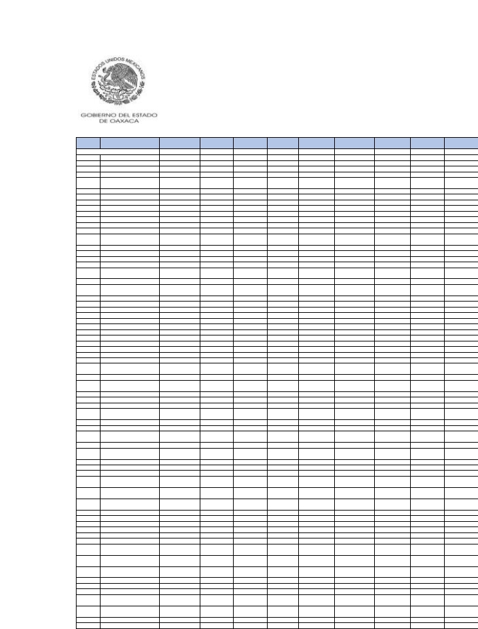Clave
municipio
70
71
72
73
74
75
76
77
78
79
80
81
82
83
84
85
86
87
88
89
90
91
92
93
94
95
96
97
98
99
100
101
102
103
104
105
106
107
108
109
110
111
112
113
114
115
116
117
118
119
120
121
122
123
124
125
126
127
128
129
130
131
132
133
134
135
136

Nombre del municipio
PINOTEPADE DONLUIS
PLUMAHIDALGO
SANJOSÉ DEL PROGRESO
PUTLAVILLADEGUERRERO
SANTACATARINA
QUIOQUITANI
REFORMADE PINEDA
LAREFORMA
REYESETLA
ROJASDE CUAUHTÉMOC
SALINACRUZ
SANAGUSTÍNAMATENGO
SANAGUSTÍNATENANGO
SANAGUSTÍNCHAYUCO
SANAGUSTÍNDE LASJUNTAS
SANAGUSTÍNETLA
SANAGUSTÍNLOXICHA
SANAGUSTÍNTLACOTEPEC
SANAGUSTÍNYATARENI
SANANDRÉSCABECERA
NUEVA
SANANDRÉSDINICUITI
SANANDRÉSHUAXPALTEPEC
SANANDRÉSHUAYÁPAM
SANANDRÉSIXTLAHUACA
SANANDRÉSLAGUNAS
SANANDRÉSNUXIÑO
SANANDRÉSPAXTLÁN
SANANDRÉSSINAXTLA
SANANDRÉSSOLAGA
SANANDRÉSTEOTILÁLPAM
SANANDRÉSTEPETLAPA
SANANDRÉSYAÁ
SANANDRÉSZABACHE
SANANDRÉSZAUTLA
SANANTONINOCASTILLO
VELASCO
SANANTONINOEL ALTO
SANANTONINOMONTE
VERDE
SANANTONIOACUTLA
SANANTONIODELACAL
SANANTONIOHUITEPEC
SANANTONIO
NANAHUATÍPAM
SANANTONIOSINICAHUA
SANANTONIOTEPETLAPA
SANBALTAZARCHICHICÁPAM
SANBALTAZARLOXICHA
SANBALTAZARYATZACHI EL
BAJO
SANBARTOLOCOYOTEPEC
SANBARTOLOMÉ AYAUTLA
SANBARTOLOMÉ LOXICHA
SANBARTOLOMÉ QUIALANA
SANBARTOLOMÉ YUCUAÑE
SANBARTOLOMÉ ZOOGOCHO
SANBARTOLOSOYALTEPEC
SANBARTOLOYAUTEPEC
SANBERNARDOMIXTEPEC
SANBLASATEMPA
SANCARLOSYAUTEPEC
SANCRISTÓBAL AMATLÁN
SANCRISTÓBAL AMOLTEPEC
SANCRISTÓBALLACHIRIOAG
SANCRISTÓBAL
SUCHIXTLAHUACA
SANDIONISIODEL MAR
SANDIONISIOOCOTEPEC
SANDIONISIO OCOTLÁN
SANESTEBANATATLAHUCA
SANFELIPE JALAPADEDÍAZ
SANFELIPE TEJALÁPAM
SANFELIPE USILA

FGP 2021
Monto
4,250,624
3,754,009
23,544,524
24,217,122
1,188,106
4,583,860
2,549,183
2,554,318
1,795,610
105,996,272
1,461,453
1,628,954
2,893,969
6,016,897
4,035,736
13,403,655
1,231,409
2,747,207
2,407,239
1,684,616
4,418,222
4,820,879
1,709,526
991,086
1,701,661
3,060,407
1,217,462
1,560,871
3,064,549
1,332,417
1,143,837
1,303,355
2,680,684
6,059,960
3,223,123
4,175,106
819,976
13,000,002
3,045,961
1,140,488
1,853,704
3,444,263
4,220,138
3,348,609
1,041,521
5,860,370
2,931,924
2,025,915
5,132,823
995,556
1,137,488
1,124,599
981,489
2,026,365
11,989,021
8,498,922
3,271,259
1,674,321
1,392,013
2,219,247
4,115,081
7,927,662
1,789,291
2,979,768
14,188,127
4,654,934
7,165,681

FIEPS 2021
Monto
53,987
58,622
223,621
282,925
20,325
50,013
33,717
32,449
22,034
1,075,364
22,387
23,371
40,393
65,622
43,400
161,447
18,292
34,489
35,719
24,166
53,610
58,925
24,426
14,244
24,665
42,975
14,807
22,508
43,199
23,095
19,707
21,638
33,918
79,560
39,139
55,490
12,593
132,948
41,081
16,891
27,233
44,265
65,235
41,337
16,881
64,554
41,205
29,439
62,032
17,260
18,926
18,321
15,192
28,031
137,570
104,710
43,967
24,828
21,824
22,844
60,100
107,664
24,521
42,140
175,094
55,627
92,114

FISAN 2021
Monto
18,289
16,511
101,494
103,618
5,300
19,248
10,964
10,912
7,648
450,612
6,425
7,093
12,565
25,675
17,120
57,517
5,394
11,805
10,534
7,329
18,833
20,998
7,464
4,329
7,407
13,286
5,145
6,811
13,332
5,959
5,109
5,785
11,507
26,654
13,747
18,042
3,604
54,735
13,166
4,988
8,080
14,686
18,525
14,375
4,617
24,933
12,756
8,843
21,844
4,461
5,064
4,987
4,309
8,784
51,054
36,455
14,135
7,287
6,162
9,261
17,968
34,224
7,722
12,993
60,753
20,001
30,771

FOCOISAN 2021
Monto
8,350
10,140
8,377
41,582
3,600
8,572
5,742
5,641
3,138
165,821
3,837
3,970
6,680
7,803
5,569
23,541
3,290
5,329
6,113
4,078
8,357
8,798
4,221
2,352
4,279
7,183
2,231
3,803
7,383
4,097
3,497
3,791
5,560
13,861
7,035
8,975
2,225
20,549
6,768
2,868
4,558
7,238
11,328
6,644
2,990
9,542
6,828
4,943
10,830
3,160
3,287
3,246
2,784
4,836
21,984
15,440
7,267
4,213
4,127
3,087
10,187
18,622
4,209
7,136
27,675
7,773
14,790

FOFIR 2021
Monto
212,756
200,923
1,187,018
1,186,944
66,231
205,201
127,322
124,728
88,399
4,919,544
78,024
84,376
148,978
294,172
193,725
664,552
64,442
136,892
126,640
87,342
215,540
245,767
88,815
51,867
88,142
157,524
58,709
81,294
158,075
74,813
63,960
71,731
132,849
313,731
155,158
211,565
43,574
596,227
154,460
60,040
96,888
169,136
224,610
165,516
56,750
281,280
151,530
105,859
246,805
55,793
62,977
61,353
52,001
103,418
576,696
422,517
165,649
87,333
74,523
102,217
215,128
399,850
90,371
154,441
699,002
231,773
357,098

FFM 2021
Monto
2,339,959
2,355,941
1,318,946
9,899,743
621,552
1,881,298
1,128,904
910,575
663,614
23,948,937
658,070
654,547
668,986
2,047,413
1,192,675
3,094,114
716,189
1,886,408
879,133
460,963
2,090,989
2,729,626
737,834
401,138
681,675
1,255,627
392,115
688,842
630,953
728,773
597,955
633,457
830,515
2,444,311
1,497,092
735,350
380,406
5,756,297
1,124,021
520,973
634,435
1,442,152
2,247,636
2,026,435
471,400
2,709,415
724,594
882,015
1,616,501
538,668
625,459
496,011
602,529
1,082,300
3,866,567
3,220,563
1,157,610
595,529
817,486
1,009,919
1,530,815
2,766,157
808,885
1,061,050
6,260,067
626,602
4,211,587

FOCO2021
Monto
195,062
87,530
200,511
873,833
13,185
71,378
88,598
97,079
26,476
2,086,511
40,882
50,319
113,727
224,379
93,560
808,914
25,484
115,592
86,514
57,112
166,558
124,728
41,272
12,669
46,494
133,065
17,671
47,023
131,048
14,201
12,240
21,465
116,547
171,553
74,435
201,603
6,946
551,763
130,978
31,615
44,924
124,699
70,549
81,450
17,966
218,860
137,733
70,549
73,537
11,304
9,120
17,963
16,260
78,127
555,287
343,596
157,456
30,851
32,149
9,225
148,707
296,875
27,911
106,860
864,460
206,386
316,988

FOGADI2021
Monto
119,375
45,353
930,514
711,957
7,479
63,662
53,981
58,019
33,327
2,962,724
23,330
29,166
65,075
215,315
116,277
440,855
16,956
76,847
43,710
32,960
112,843
150,563
30,783
14,273
28,079
66,513
18,861
28,677
68,551
7,574
6,532
11,416
72,792
166,769
61,048
114,180
7,244
427,556
71,337
20,066
26,632
68,551
44,977
74,955
10,708
191,030
68,462
38,092
82,184
5,990
8,327
10,758
10,457
43,664
355,487
235,249
80,521
18,684
19,187
38,873
79,174
166,696
24,472
62,144
440,912
153,815
187,784

LISRM
Monto
2,538
868
37,725
18,376
140
1,718
1,094
1,078
1,026
94,301
453
591
1,253
5,760
3,516
9,751
380
1,673
816
621
2,532
4,485
721
434
545
1,240
544
604
1,279
148
122
212
1,469
4,930
1,649
2,155
219
9,721
1,401
400
587
1,348
996
2,103
219
4,798
1,279
757
2,615
112
233
216
210
844
8,369
5,569
1,521
426
370
1,547
1,471
3,160
649
1,318
8,410
3,660
3,701

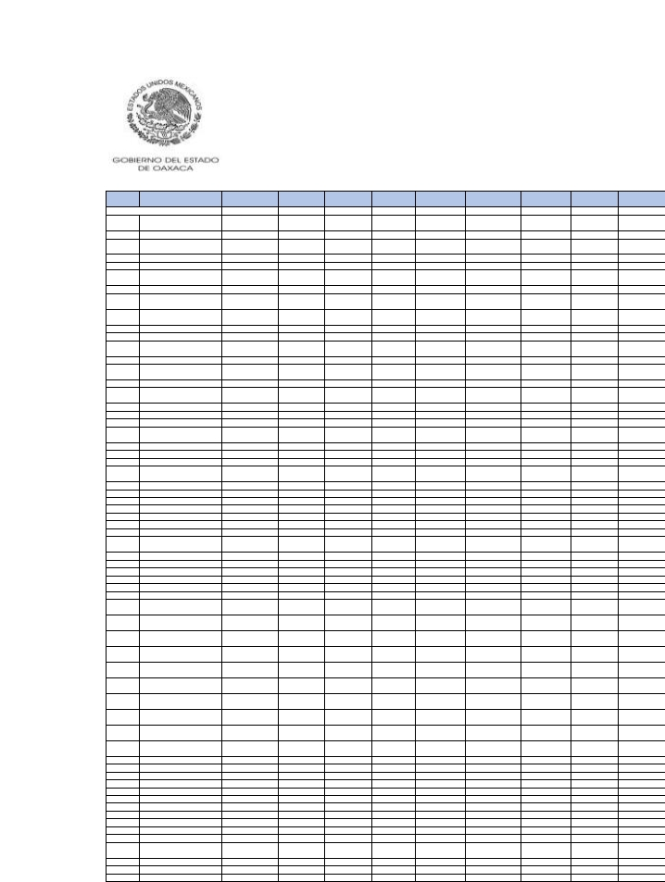Clave
municipio
137
138
139
140
141
142
143
144
145
146
147
148
149
150
151
152
153
154
155
156
157
158
159
160
161
162
163
164
165
166
167
168
169
170
171
172
173
174
175
176
177
178
179
180
181
182
183
184
185
186
187
188
189
190
191
192
193
194
195
196
197
198
199

Nombre del municipio

SANFRANCISCOCAHUACUÁ
SANFRANCISCOCAJONOS
SANFRANCISCOCHAPULAPA
SANFRANCISCOCHINDÚA
SANFRANCISCODEL MAR
SANFRANCISCOHUEHUETLÁN
SANFRANCISCOIXHUATÁN
SANFRANCISCO
JALTEPETONGO
SANFRANCISCOLACHIGOLÓ
SANFRANCISCOLOGUECHE
SANFRANCISCONUXAÑO
SANFRANCISCOOZOLOTEPEC
SANFRANCISCOSOLA
SANFRANCISCO
TELIXTLAHUACA
SANFRANCISCOTEOPAN
SANFRANCISCOTLAPANCINGO
SANGABRIEL MIXTEPEC
SANILDEFONSOAMATLÁN
SANILDEFONSOSOLA
SANILDEFONSOVILLAALTA
SANJACINTOAMILPAS
SANJACINTOTLACOTEPEC
SANJERÓNIMOCOATLÁN
SANJERÓNIMO
SILACAYOAPILLA
SANJERÓNIMOSOSOLA
SANJERÓNIMOTAVICHE
SANJERÓNIMOTECÓATL
SANJORGE NUCHITA
SANJOSÉ AYUQUILA
SANJOSÉ CHILTEPEC
SANJOSÉ DEL PEÑASCO
SANJOSÉ ESTANCIAGRANDE
SANJOSÉ INDEPENDENCIA
SANJOSÉ LACHIGUIRI
SANJOSÉ TENANGO
SANJUANACHIUTLA
SANJUANATEPEC
ÁNIMASTRUJANO
SANJUANBAUTISTA
ATATLAHUCA
SANJUANBAUTISTA
COIXTLAHUACA
SANJUANBAUTISTA
CUICATLÁN
SANJUANBAUTISTA
GUELACHE
SANJUANBAUTISTA
JAYACATLÁN
SANJUANBAUTISTALODE
SOTO
SANJUANBAUTISTA
SUCHITEPEC
SANJUANBAUTISTA
TLACOATZINTEPEC
SANJUANBAUTISTA
TLACHICHILCO
SANJUANBAUTISTATUXTEPEC
SANJUANCACAHUATEPEC
SANJUANCIENEGUILLA
SANJUANCOATZÓSPAM
SANJUANCOLORADO
SANJUANCOMALTEPEC
SANJUANCOTZOCÓN
SANJUANCHICOMEZÚCHIL
SANJUANCHILATECA
SANJUANDELESTADO
SANJUANDEL RÍO
SANJUANDIUXI
SANJUANEVANGELISTA
ANALCO
SANJUANGUELAVÍA
SANJUANGUICHICOVI
SANJUANIHUALTEPEC

FGP 2021
Monto
4,079,036
848,543
2,004,511
900,336
5,842,722
1,251,957
8,096,949
1,027,116
3,795,233
2,397,581
1,582,236
3,237,208
1,616,655
6,534,920
788,103
1,762,145
2,944,797
2,510,289
1,430,717
2,683,740
15,154,933
2,572,945
3,451,979
1,779,141
2,134,169
1,624,418
1,493,762
2,178,139
1,582,202
7,432,134
1,822,389
1,156,131
3,002,578
3,518,341
12,035,394
623,474
1,456,834
2,740,525
1,573,631
3,008,061
6,502,434
3,546,306
1,774,658
1,892,439
1,013,644
1,847,825
1,558,794
208,026,958
5,247,715
1,172,122
1,870,998
5,472,762
2,552,594
13,516,611
565,089
1,546,625
2,269,598
2,087,738
1,931,894
887,708
3,717,930
17,763,640
1,098,686

FIEPS 2021
Monto
50,012
14,241
30,658
14,083
73,899
19,599
89,818
15,823
42,141
34,780
23,178
39,778
23,221
75,473
13,264
26,016
39,290
34,947
22,561
38,206
156,714
36,721
45,167
23,880
31,200
23,298
22,478
30,968
23,425
95,313
25,803
18,191
43,275
44,759
150,689
9,569
20,342
32,691
23,862
42,421
84,041
42,361
25,870
27,089
15,897
27,202
23,555
2,202,560
67,172
19,567
27,848
69,520
33,421
167,328
9,462
21,567
29,060
26,684
28,622
14,648
47,436
213,648
18,039

FISAN 2021
Monto
17,617
3,785
8,810
3,970
25,272
5,520
34,713
4,518
16,137
10,475
6,927
13,928
7,048
27,709
3,503
7,703
12,731
10,906
6,323
11,734
63,769
11,354
14,845
7,641
9,323
7,058
6,544
9,474
6,907
32,094
7,941
5,100
13,099
14,902
51,867
2,754
6,297
11,687
6,902
13,103
28,153
15,122
7,778
8,256
4,470
8,074
6,838
873,888
22,614
5,214
8,170
23,551
11,095
58,080
2,525
6,726
9,855
8,963
8,442
3,949
15,987
75,901
4,867

FOCOISAN 2021
Monto
7,739
2,616
5,285
2,445
10,598
3,396
15,620
2,869
7,713
5,982
3,802
5,171
4,179
11,424
2,343
4,438
6,390
5,892
3,857
6,673
24,606
6,461
7,376
4,065
5,247
3,918
3,861
5,273
3,959
14,460
4,219
3,129
7,223
7,444
22,490
1,577
3,529
4,993
4,115
7,240
13,270
6,571
4,283
4,465
2,733
4,625
4,082
307,928
10,507
3,449
4,900
10,943
4,877
25,270
1,738
3,776
4,208
5,038
5,631
2,548
7,744
31,783
3,171

FOFIR 2021
Monto
204,171
46,864
106,704
48,416
296,940
67,237
373,642
54,570
178,717
125,106
83,360
163,393
83,396
313,676
43,543
92,529
149,326
129,069
77,447
139,442
701,471
135,818
172,641
88,881
111,866
84,011
78,909
112,435
82,931
375,806
94,649
62,420
156,576
170,085
604,410
33,672
74,037
133,579
83,442
155,438
329,570
172,603
93,612
98,743
54,557
96,939
82,429
9,724,052
263,489
64,688
97,821
273,528
131,457
673,137
31,232
79,360
116,311
102,139
99,719
48,922
185,065
872,297
60,058

FFM 2021
Monto
1,123,393
477,307
642,348
400,933
1,297,788
480,582
2,993,444
422,753
1,160,705
1,219,125
799,250
962,754
827,556
1,196,533
360,905
578,885
763,061
1,092,184
814,711
1,212,278
3,406,965
791,037
880,631
721,505
920,975
512,472
1,088,289
598,030
949,836
3,201,406
728,656
457,675
1,110,363
1,420,442
2,851,085
277,275
656,362
1,007,549
715,912
1,337,003
1,739,396
993,507
830,357
837,096
529,639
593,911
801,513
81,759,084
2,385,911
630,209
598,102
840,686
642,392
4,959,553
285,150
725,999
588,353
867,428
782,253
469,037
1,628,871
9,640,579
510,453

FOCO2021
Monto
95,556
12,243
61,790
22,048
216,150
29,543
240,142
26,563
96,296
82,044
10,205
57,967
51,835
313,066
8,913
65,753
134,452
67,301
30,237
86,958
348,167
66,102
150,227
37,528
71,859
58,747
47,756
79,993
43,072
320,620
60,972
29,876
131,370
105,728
675,163
10,063
40,854
93,620
44,741
77,093
270,123
169,899
40,750
70,367
12,291
63,220
41,418
4,034,377
238,489
14,831
55,349
295,757
88,149
677,319
8,623
36,197
67,393
33,633
32,285
10,663
88,898
874,910
17,248

FOGADI2021
Monto
101,243
7,076
31,584
12,628
165,746
16,012
189,857
14,655
95,415
45,741
17,795
74,059
28,318
208,914
5,115
32,681
77,076
46,886
17,957
56,978
408,051
55,117
81,920
27,073
40,605
29,973
24,554
43,501
24,604
216,328
36,368
16,619
61,447
53,359
350,421
8,964
24,097
74,541
24,952
53,625
183,956
111,399
30,998
41,685
9,932
34,173
22,912
4,916,957
150,172
9,160
27,923
163,050
66,355
414,497
5,322
28,744
62,320
32,660
20,309
7,887
75,348
527,006
9,222

LISRM
Monto
3,096
138
587
245
4,258
315
4,795
272
2,662
917
631
2,468
565
4,124
98
610
1,491
1,112
402
1,201
11,675
1,525
1,631
641
797
559
456
825
488
4,750
798
315
1,184
1,069
8,184
245
485
1,733
476
1,297
4,170
2,199
787
815
262
648
464
150,973
3,122
188
519
3,231
1,778
8,907
104
674
1,710
943
471
184
2,037
11,612
178

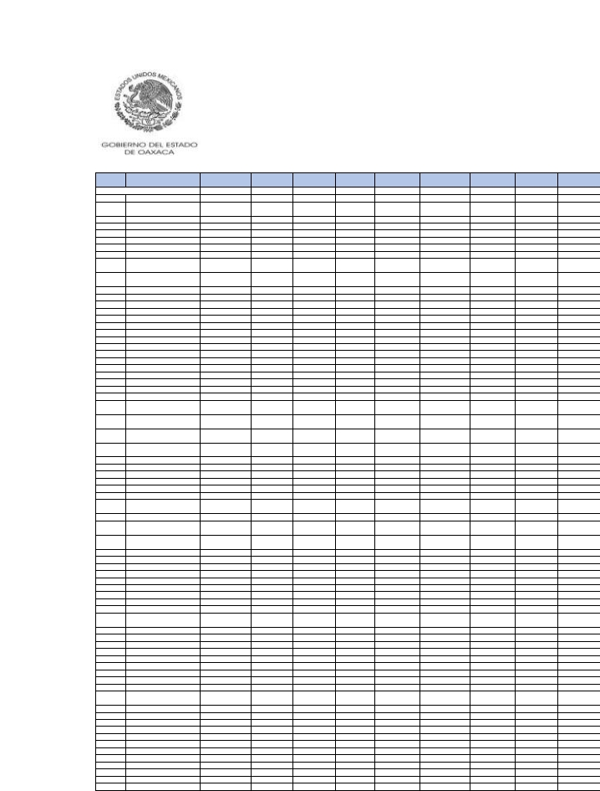Clave
municipio
200
201
202
203
204
205
206
207
208
209
210
211
212
213
214
215
216
217
218
219
220
221
222
223
224
225
226
227
228
229
230
231
232
233
234
235
236
237
238
239
240
241
242
243
244
245
246
247
248
249
250
251
252
253
254
255
256
257
258
259
260
261
262
263
264
265
266
267
268
269
270
271

Nombre del municipio
SANJUANJUQUILAMIXES
SANJUANJUQUILAVIJANOS
SANJUANLACHAO
SANJUANLACHIGALLA
SANJUANLAJARCIA
SANJUANLALANA
SANJUANDE LOSCUÉS
SANJUANMAZATLÁN
SANJUANMIXTEPEC(DTO
JUXTLAHUACA)
SANJUANMIXTEPEC(DTO
MIAHUATLÁN)
SANJUANÑUMÍ
SANJUANOZOLOTEPEC
SANJUANPETLAPA
SANJUANQUIAHIJE
SANJUANQUIOTEPEC
SANJUANSAYULTEPEC
SANJUANTABAÁ
SANJUANTAMAZOLA
SANJUANTEITA
SANJUANTEITIPAC
SANJUANTEPEUXILA
SANJUANTEPOSCOLULA
SANJUANYAEÉ
SANJUANYATZONA
SANJUANYUCUITA
SANLORENZO
SANLORENZOALBARRADAS
SANLORENZOCACAOTEPEC
SANLORENZO
CUAUNECUILTITLA
SANLORENZOTEXMELÚCAN
SANLORENZOVICTORIA
SANLUCASCAMOTLÁN
SANLUCASOJITLÁN
SANLUCASQUIAVINÍ
SANLUCASZOQUIÁPAM
SANLUIS AMATLÁN
SANMARCIAL OZOLOTEPEC
SANMARCOSARTEAGA
SANMARTÍNDELOS
CANSECOS
SANMARTÍNHUAMELÚLPAM
SANMARTÍNITUNYOSO
SANMARTÍNLACHILÁ
SANMARTÍNPERAS
SANMARTÍNTILCAJETE
SANMARTÍNTOXPALAN
SANMARTÍNZACATEPEC
SANMATEOCAJONOS
CAPULÁLPAMDE MÉNDEZ
SANMATEODEL MAR
SANMATEOYOLOXOCHITLÁN
SANMATEOETLATONGO
SANMATEONEJÁPAM
SANMATEOPEÑASCO
SANMATEOPIÑAS
SANMATEORÍO HONDO
SANMATEOSINDIHUI
SANMATEOTLAPILTEPEC
SANMELCHORBETAZA
SANMIGUEL ACHIUTLA
SANMIGUEL AHUEHUETITLÁN
SANMIGUEL ALOÁPAM
SANMIGUEL AMATITLÁN
SANMIGUEL AMATLÁN
SANMIGUEL COATLÁN
SANMIGUEL CHICAHUA
SANMIGUEL CHIMALAPA
SANMIGUEL DELPUERTO
SANMIGUEL DEL RÍO
SANMIGUEL EJUTLA
SANMIGUEL ELGRANDE
SANMIGUEL HUAUTLA
SANMIGUEL MIXTEPEC

FGP 2021
Monto
2,767,939
1,597,694
3,231,940
2,606,527
1,251,583
10,217,082
1,746,016
11,197,445
4,898,864
1,505,143
4,971,128
2,267,234
2,396,854
3,136,489
1,996,980
1,051,094
1,579,143
2,836,571
1,116,790
2,398,759
2,645,419
1,264,417
1,476,084
1,023,523
785,436
3,792,510
2,130,856
11,958,823
1,428,050
4,828,119
1,203,966
2,795,475
14,005,278
2,356,718
4,567,618
3,118,345
1,875,757
1,808,381
1,383,708
1,257,112
2,117,221
1,374,444
7,282,398
2,278,894
2,373,143
1,258,436
1,023,188
2,056,628
8,022,150
2,442,506
2,078,468
1,586,998
1,824,403
2,268,930
2,660,789
1,880,191
960,946
1,409,582
1,370,721
2,313,430
1,849,454
4,443,814
1,104,087
2,888,796
1,975,990
4,256,850
5,253,548
769,659
1,326,304
3,966,660
2,106,210
2,162,478

FIEPS 2021
Monto
39,271
23,743
43,110
38,014
16,749
133,201
24,771
139,641
67,984
23,771
64,085
32,143
35,569
40,163
29,132
14,273
24,027
40,268
18,501
35,660
36,702
18,664
21,799
16,577
12,594
51,637
28,086
125,867
23,778
63,304
17,494
37,222
178,887
31,347
61,859
44,491
27,980
26,690
22,337
17,492
31,853
20,220
94,736
32,001
32,488
19,283
16,996
22,739
98,281
33,609
25,566
25,293
27,173
35,240
37,781
26,807
14,940
22,663
19,513
33,304
27,056
58,602
16,444
38,456
29,160
58,188
66,852
13,160
19,516
52,053
28,904
30,846

FISAN 2021
Monto
12,040
6,997
13,943
11,390
5,455
44,592
7,623
48,076
21,248
6,651
21,507
9,830
10,492
13,377
8,721
4,536
6,923
12,331
4,952
10,521
11,510
5,520
6,452
4,531
3,468
16,423
9,181
50,785
6,357
20,894
5,251
12,174
59,867
10,126
19,754
13,563
8,207
7,957
6,129
5,477
9,281
5,999
31,388
9,932
10,284
5,529
4,550
8,496
34,367
10,600
8,753
7,007
7,992
9,993
11,577
8,149
4,226
6,242
6,007
10,052
8,071
19,185
4,867
12,413
8,633
18,445
22,459
3,439
5,808
16,914
9,268
9,403

FOCOISAN 2021
Monto
6,611
4,019
6,976
6,463
2,372
21,516
4,312
22,309
11,431
4,075
9,547
5,522
6,057
6,671
5,044
2,618
4,112
7,216
3,286
6,113
6,063
3,191
3,706
2,886
2,210
8,532
4,442
16,673
4,142
9,870
2,856
5,610
29,722
4,872
10,306
7,387
5,144
4,438
3,891
2,973
5,472
3,470
15,102
5,627
5,379
3,306
2,975
3,471
15,117
5,640
4,500
4,482
4,629
6,086
6,592
4,633
2,612
4,062
3,091
5,726
4,667
9,466
2,860
6,353
4,970
9,629
10,896
2,350
3,273
9,021
4,513
5,309

FOFIR 2021
Monto
143,140
84,275
163,314
136,341
65,179
516,634
90,483
554,895
250,891
81,537
252,763
116,289
126,272
153,675
104,166
52,697
83,698
145,419
61,231
126,682
136,493
66,191
77,414
55,740
42,547
193,363
107,444
571,936
78,946
245,377
63,039
144,547
688,942
118,609
231,880
161,660
97,925
96,235
75,371
64,876
111,913
71,883
366,202
117,462
121,242
67,128
56,395
93,144
395,946
124,993
98,191
85,651
96,211
121,562
137,047
96,431
51,237
76,533
72,226
119,475
96,508
224,517
58,667
144,703
103,489
217,359
258,860
42,874
69,786
194,441
111,210
111,502

FFM 2021
Monto
691,946
455,719
1,102,333
756,104
457,595
4,296,052
744,555
2,374,501
1,450,548
770,219
742,570
804,980
652,231
1,070,844
681,996
601,431
835,929
708,287
618,135
1,122,911
1,217,231
775,498
651,757
877,451
456,634
747,000
1,395,687
4,016,740
671,400
1,378,282
517,686
660,463
6,147,313
1,529,254
821,114
1,461,121
1,097,096
777,682
772,430
496,499
663,564
725,834
962,914
1,154,113
611,227
422,018
487,200
760,026
2,020,680
993,658
817,726
734,618
598,152
850,949
1,260,290
563,347
476,741
694,114
632,423
1,384,661
548,666
3,963,708
410,164
1,275,864
1,053,311
726,067
7,017,937
448,357
610,475
2,729,370
733,865
582,994

FOCO2021
Monto
108,549
56,220
136,088
97,300
16,224
504,020
67,289
566,788
196,811
19,991
162,679
82,338
89,742
124,676
59,256
20,065
34,840
91,470
15,339
75,599
73,234
33,201
39,403
11,662
14,458
185,723
75,082
367,289
24,445
265,504
25,525
90,751
600,246
52,387
231,493
107,105
49,757
37,418
22,757
27,582
75,562
30,358
414,786
47,212
105,721
37,108
18,255
36,854
521,204
105,207
29,802
34,429
62,557
63,304
90,188
60,393
6,016
28,644
19,149
73,811
61,447
224,102
25,688
97,315
62,475
201,349
238,684
6,286
27,965
110,487
33,753
81,590

FOGADI2021
Monto
58,452
30,175
76,507
51,280
25,173
272,319
39,228
324,864
106,441
15,643
126,305
41,139
45,077
66,357
33,756
16,002
21,364
48,128
8,408
43,421
52,833
20,158
24,364
8,867
8,756
94,550
48,589
396,174
13,228
139,501
18,887
69,174
320,256
38,716
111,958
60,145
25,681
31,940
14,554
22,967
35,491
19,991
198,919
39,415
58,483
19,851
9,561
28,529
247,699
57,537
23,182
17,890
32,477
32,588
50,766
31,263
7,012
16,144
23,176
38,138
33,677
120,472
19,590
55,393
33,201
105,339
130,291
4,285
20,460
63,981
45,381
41,121

LISRM
Monto
1,108
561
1,527
969
859
5,312
766
6,752
2,059
426
3,277
764
837
1,237
706
392
436
986
161
880
1,281
404
490
203
163
1,765
1,065
11,154
265
2,863
458
1,866
6,199
1,014
2,080
1,214
518
841
305
609
659
451
3,938
1,012
1,086
377
179
644
5,062
1,112
581
338
619
615
1,002
583
218
323
732
750
629
2,335
469
1,185
637
1,959
2,449
92
499
1,202
1,549
771

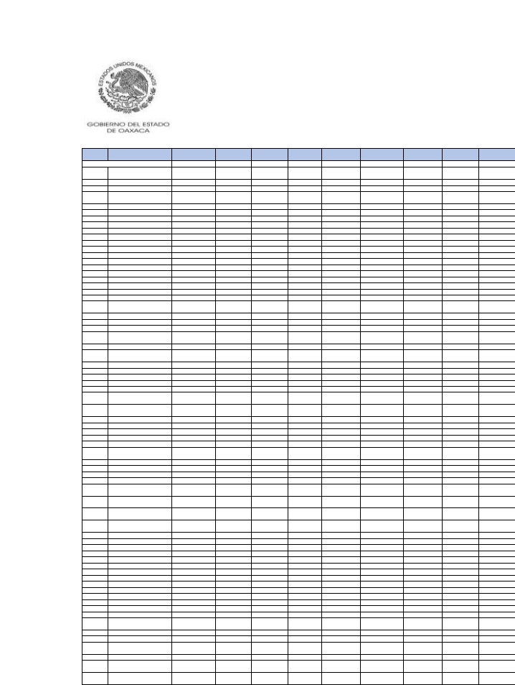Clave
municipio
272
273
274
275
276
277
278
279
280
281
282
283
284
285
286
287
288
289
290
291
292
293
294
295
296
297
298
299
300
301
302
303
304
305
306
307
308
309
310
311
312
313
314
315
316
317
318
319
320
321
322
323
324
325
326
327
328
329
330
331
332
333
334
335
336
337
338
339
340

Nombre del municipio

SANMIGUEL PANIXTLAHUACA
SANMIGUEL PERAS
SANMIGUEL PIEDRAS
SANMIGUEL QUETZALTEPEC
SANMIGUEL SANTAFLOR
VILLASOLADE VEGA
SANMIGUEL SOYALTEPEC
SANMIGUEL SUCHIXTEPEC
VILLATALEADE CASTRO
SANMIGUEL TECOMATLÁN
SANMIGUEL TENANGO
SANMIGUEL TEQUIXTEPEC
SANMIGUEL TILQUIÁPAM
SANMIGUEL TLACAMAMA
SANMIGUEL TLACOTEPEC
SANMIGUEL TULANCINGO
SANMIGUEL YOTAO
SANNICOLÁS
SANNICOLÁSHIDALGO
SANPABLOCOATLÁN
SANPABLOCUATROVENADOS
SANPABLOETLA
SANPABLOHUITZO
SANPABLOHUIXTEPEC
SANPABLOMACUILTIANGUIS
SANPABLOTIJALTEPEC
SANPABLOVILLADE MITLA
SANPABLOYAGANIZA
SANPEDROAMUZGOS
SANPEDROAPÓSTOL
SANPEDROATOYAC
SANPEDROCAJONOS
SANPEDROCOXCALTEPEC
CÁNTAROS
SANPEDROCOMITANCILLO
SANPEDROEL ALTO
SANPEDROHUAMELULA
SANPEDROHUILOTEPEC
SANPEDROIXCATLÁN
SANPEDROIXTLAHUACA
SANPEDROJALTEPETONGO
SANPEDROJICAYÁN
SANPEDROJOCOTIPAC
SANPEDROJUCHATENGO
SANPEDROMÁRTIR
SANPEDROMÁRTIR
QUIECHAPA
SANPEDROMÁRTIR
YUCUXACO
SANPEDROMIXTEPEC(DTO
JUQUILA)
SANPEDROMIXTEPEC(DTO
MIAHUATLÁN)
SANPEDROMOLINOS
SANPEDRONOPALA
SANPEDROOCOPETATILLO
SANPEDROOCOTEPEC
SANPEDROPOCHUTLA
SANPEDROQUIATONI
SANPEDROSOCHIÁPAM
SANPEDROTAPANATEPEC
SANPEDROTAVICHE
SANPEDROTEOZACOALCO
SANPEDROTEUTILA
SANPEDROTIDAÁ
SANPEDROTOPILTEPEC
SANPEDROTOTOLÁPAM
VILLADE TUTUTEPECDE
MELCHOROCAMPO
SANPEDROYANERI
SANPEDROYÓLOX
SANPEDROYSANPABLO
AYUTLA
VILLADEETLA
SANPEDROYSANPABLO
TEPOSCOLULA
SANPEDROYSANPABLO
TEQUIXTEPEC

FGP 2021
Monto
4,114,490
2,870,394
1,511,978
4,432,871
1,521,251
9,273,401
21,692,514
2,199,139
2,375,247
911,498
1,113,322
1,594,455
4,180,542
2,534,076
2,843,221
1,038,841
1,080,386
1,393,022
1,126,696
2,870,582
1,549,468
15,233,561
4,749,966
8,138,437
1,139,231
1,942,696
9,523,575
1,361,970
3,819,094
3,124,956
3,353,885
1,133,217
1,186,135
3,171,330
2,829,042
6,119,453
2,826,861
6,945,868
4,425,140
1,313,486
6,508,080
1,355,763
1,968,325
1,902,740
1,422,223
1,814,423
62,057,527
934,960
851,099
1,159,273
1,394,863
1,934,339
29,198,229
6,899,539
4,115,054
19,670,251
1,281,078
1,456,192
2,931,953
2,361,643
688,999
3,187,608
26,296,114
1,390,902
2,542,119
4,482,542
8,474,097
4,488,209
1,668,852

FIEPS 2021
Monto
50,851
38,567
24,323
57,311
24,913
120,281
261,471
31,087
33,037
12,961
17,686
23,079
66,805
34,153
41,739
16,367
17,992
22,209
16,885
39,726
24,026
154,662
54,986
94,438
17,542
28,251
110,494
21,899
48,062
45,811
43,490
17,174
18,712
36,819
39,949
75,939
34,028
91,255
50,352
20,696
82,645
22,562
25,171
27,941
23,748
25,620
615,501
13,958
13,533
17,948
23,208
27,376
305,821
83,306
54,253
248,517
19,984
22,383
40,386
29,221
11,405
37,077
305,433
22,761
35,582
54,802
89,141
39,137
25,125

FISAN 2021
Monto
17,195
12,442
6,718
19,124
6,728
39,820
92,742
9,538
10,304
3,929
4,905
7,030
18,497
10,942
12,423
4,643
4,805
6,152
4,921
12,461
6,831
64,447
20,262
34,535
5,011
8,505
40,672
6,029
16,360
13,650
14,329
4,970
5,247
13,471
12,290
26,346
11,988
30,009
18,753
5,791
27,975
6,031
8,465
8,311
6,383
7,915
266,487
4,099
3,764
5,094
6,196
8,372
123,483
29,424
17,732
84,397
5,642
6,395
12,727
10,156
3,059
13,750
112,029
6,167
11,023
19,106
35,868
18,778
7,323

FOCOISAN 2021
Monto
8,181
5,998
4,617
9,172
4,401
20,143
41,430
5,348
5,537
2,181
3,079
3,664
11,538
5,548
7,475
2,907
3,157
3,861
2,877
6,564
4,094
19,241
7,488
15,789
3,095
4,808
16,529
3,893
7,915
7,966
7,069
3,023
3,165
5,164
6,726
11,254
5,222
14,917
7,594
3,563
13,156
3,979
4,583
4,756
5,007
4,289
75,009
2,406
2,349
3,232
4,099
4,606
46,849
12,740
8,967
38,595
3,450
3,922
6,632
3,922
2,026
5,522
44,134
3,993
6,217
8,427
10,191
9,065
4,356

FOFIR 2021
Monto
200,366
147,086
81,924
223,055
82,858
460,909
1,060,843
112,763
121,736
46,315
59,945
85,147
227,215
128,462
148,035
57,083
59,564
75,444
59,224
147,371
83,240
721,856
232,488
388,103
60,644
101,883
463,867
73,959
188,268
163,182
165,642
59,847
64,372
153,871
145,849
306,505
136,574
350,578
211,735
70,738
324,269
74,731
96,958
99,583
77,789
94,199
2,920,598
49,305
46,051
61,512
76,836
99,093
1,347,378
337,105
206,667
978,399
68,790
77,347
150,481
118,860
37,859
158,242
1,279,232
76,096
129,773
219,198
406,393
175,404
88,268

FFM 2021
Monto
1,126,358
1,357,473
600,362
1,326,276
890,933
4,458,969
9,830,262
863,739
1,093,839
392,763
416,707
732,720
1,906,536
1,103,776
1,157,953
413,813
753,698
593,093
505,780
687,218
651,755
5,341,053
2,445,664
4,087,812
543,456
834,410
3,068,261
585,936
1,151,597
1,590,675
788,012
409,658
491,563
1,728,164
1,095,173
781,313
2,074,875
2,996,094
1,822,914
693,120
1,063,793
632,410
871,904
984,125
813,755
806,925
13,834,626
297,564
322,536
458,587
673,032
539,249
8,876,954
2,343,820
1,993,202
8,698,087
492,768
492,355
670,152
786,870
351,870
744,827
10,688,578
606,290
1,111,967
1,222,129
4,270,236
1,744,793
453,178

FOCO2021
Monto
180,158
101,432
38,109
239,385
21,127
379,116
1,178,276
75,474
60,572
7,018
20,787
26,765
102,179
104,079
90,589
8,087
17,109
31,491
26,443
118,368
41,583
360,056
167,230
230,766
24,749
75,406
333,885
29,131
189,454
41,244
136,454
29,923
22,763
102,305
108,708
273,936
88,333
371,985
243,034
16,293
377,112
22,567
41,374
54,403
18,772
34,177
1,206,542
30,814
18,772
20,455
24,154
59,279
1,315,416
319,965
156,720
409,819
37,386
36,098
120,879
25,021
9,326
67,597
1,264,010
25,330
49,731
149,795
256,947
103,607
46,255

FOGADI2021
Monto
115,734
65,474
19,627
130,723
11,283
209,957
666,238
41,246
42,815
7,035
11,468
30,181
52,099
58,859
48,964
13,673
9,318
17,541
15,760
67,187
23,194
482,846
145,124
193,412
14,877
40,599
272,667
16,415
105,235
37,806
70,868
16,837
14,727
86,907
57,140
186,277
61,368
189,257
143,347
12,038
194,662
12,150
36,183
29,888
12,351
30,241
1,944,557
16,671
10,586
12,155
12,208
33,004
904,365
191,148
90,957
390,291
18,655
19,327
68,917
46,688
5,771
89,319
837,970
14,067
36,494
99,956
274,392
70,995
27,107

LISRM
Monto
2,560
1,581
365
2,561
221
4,348
13,701
769
984
203
218
927
1,054
1,151
912
479
177
326
310
1,289
466
14,812
3,604
4,822
304
802
7,034
305
2,013
1,063
1,336
313
357
2,148
1,119
4,244
1,457
3,746
2,939
313
3,700
229
971
648
270
837
65,801
312
203
251
227
628
21,041
4,151
1,979
11,122
347
369
1,369
1,690
119
2,867
18,670
262
932
2,492
7,787
1,541
532

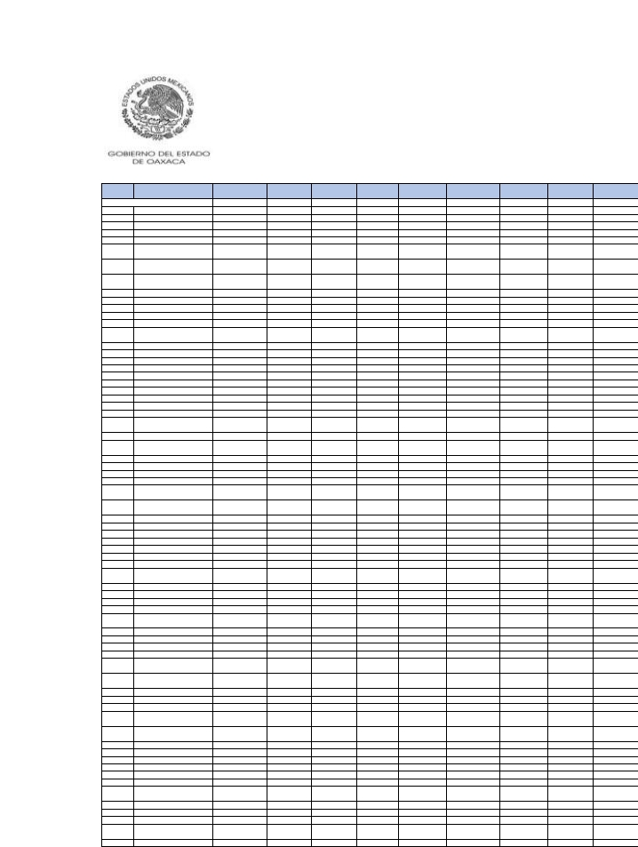Clave
municipio
341
342
343
344
345
346
347
348
349
350
351
352
353
354
355
356
357
358
359
360
361
362
363
364
365
366
367
368
369
370
371
372
373
374
375
376
377
378
379
380
381
382
383
384
385
386
387
388
389
390
391
392
393
394
395
396
397
398
399
400
401
402
403
404
405
406
407
408
409

Nombre del municipio
SANPEDROYUCUNAMA
SANRAYMUNDOJALPAN
SANSEBASTIÁNABASOLO
SANSEBASTIÁNCOATLÁN
SANSEBASTIÁNIXCAPA
SANSEBASTIÁNNICANANDUTA
SANSEBASTIÁNRÍO HONDO
SANSEBASTIÁN
TECOMAXTLAHUACA
SANSEBASTIÁNTEITIPAC
SANSEBASTIÁNTUTLA
SANSIMÓNALMOLONGAS
SANSIMÓNZAHUATLÁN
SANTAANA
SANTAANAATEIXTLAHUACA
SANTAANACUAUHTÉMOC
SANTAANADELVALLE
SANTAANATAVELA
SANTAANATLAPACOYAN
SANTAANAYARENI
SANTAANAZEGACHE
SANTACATALINAQUIERÍ
SANTACATARINACUIXTLA
SANTACATARINAIXTEPEJI
SANTACATARINAJUQUILA
SANTACATARINALACHATAO
SANTACATARINALOXICHA
SANTACATARINA
MECHOACÁN
SANTACATARINAMINAS
SANTACATARINAQUIANÉ
SANTACATARINATAYATA
SANTACATARINATICUÁ
SANTACATARINAYOSONOTÚ
SANTACATARINAZAPOQUILA
SANTACRUZ ACATEPEC
SANTACRUZ AMILPAS
SANTACRUZ DE BRAVO
SANTACRUZITUNDUJIA
SANTACRUZ MIXTEPEC
SANTACRUZ NUNDACO
SANTACRUZPAPALUTLA
SANTACRUZ TACACHE DE
MINA
SANTACRUZ TACAHUA
SANTACRUZ TAYATA
SANTACRUZ XITLA
SANTACRUZXOXOCOTLÁN
SANTACRUZZENZONTEPEC
SANTAGERTRUDIS
SANTAINÉSDEL MONTE
SANTAINÉSYATZECHE
SANTALUCÍADEL CAMINO
SANTALUCÍAMIAHUATLÁN
SANTALUCÍAMONTEVERDE
SANTALUCÍAOCOTLÁN
SANTAMARÍAALOTEPEC
SANTAMARÍAAPAZCO
SANTAMARÍALAASUNCIÓN
HEROICACIUDADDE TLAXIACO
AYOQUEZCODE ALDAMA
SANTAMARÍAATZOMPA
SANTAMARÍACAMOTLÁN
SANTAMARÍACOLOTEPEC
SANTAMARÍACORTIJO
SANTAMARÍACOYOTEPEC
SANTAMARÍACHACHOÁPAM
VILLADE CHILAPADEDÍAZ
SANTAMARÍACHILCHOTLA
SANTAMARÍACHIMALAPA
SANTAMARÍADEL ROSARIO
SANTAMARÍADEL TULE

FGP 2021
Monto
1,258,677
5,249,269
2,134,886
2,434,546
2,848,257
1,960,157
2,632,371
6,213,837
1,661,331
14,548,883
2,271,593
2,553,021
1,873,031
1,137,176
1,125,655
2,531,415
1,536,915
2,534,026
1,565,948
3,307,223
1,430,151
1,855,574
2,150,000
9,603,326
1,236,055
3,912,164
3,008,355
3,521,386
1,699,389
1,375,159
1,593,002
1,836,049
928,669
1,420,100
9,814,229
803,625
7,098,793
2,418,473
2,200,455
1,709,875
1,911,974
1,391,254
1,015,765
3,112,363
85,197,730
15,178,407
2,293,848
2,149,874
1,765,459
39,966,123
2,624,771
4,495,313
2,897,934
1,912,447
1,928,071
2,622,852
30,785,144
4,311,695
23,519,458
2,099,900
18,992,343
1,221,935
3,118,465
1,596,792
2,492,053
12,677,599
5,220,053
1,022,857
16,526,717

FIEPS 2021
Monto
17,744
49,600
29,407
32,667
38,328
24,662
36,208
81,651
24,548
164,229
32,100
35,873
26,782
19,090
18,551
35,174
22,682
35,893
22,302
45,858
23,269
25,410
30,424
116,806
17,764
48,870
41,621
55,963
23,263
18,020
23,540
28,362
15,826
21,626
97,976
13,075
89,742
32,527
31,072
23,825
25,461
21,803
15,890
42,245
833,500
171,455
29,736
31,954
29,029
452,904
37,859
60,620
38,879
26,772
30,071
38,345
335,330
52,692
232,480
25,947
184,343
19,203
34,089
20,999
29,543
166,358
67,110
15,363
161,072

FISAN 2021
Monto
5,530
21,328
9,277
10,494
12,291
8,338
11,431
26,743
7,268
61,806
9,907
11,089
8,145
5,060
4,995
10,956
6,698
11,008
6,814
14,371
6,343
8,017
9,355
40,809
5,366
16,710
13,043
15,518
7,408
5,882
6,953
8,074
4,144
6,242
41,236
3,557
30,548
10,450
9,572
7,451
8,219
6,126
4,504
13,497
357,845
63,801
9,843
9,400
7,857
172,555
11,446
19,423
12,516
8,319
8,495
11,463
129,989
18,431
99,081
8,850
80,251
5,392
13,224
6,918
10,639
54,601
21,938
4,476
70,613

FOCOISAN 2021
Monto
3,318
6,257
4,887
5,637
6,251
4,103
5,871
12,996
4,184
26,815
5,186
6,080
4,609
3,344
3,245
5,868
4,304
6,101
3,816
7,650
4,095
4,283
5,270
18,358
3,277
9,660
6,956
9,626
3,638
3,021
4,107
4,940
2,800
3,693
12,356
2,307
13,737
5,415
5,167
3,764
4,283
3,779
3,382
6,816
119,208
28,083
4,982
5,466
5,014
60,411
6,411
10,304
6,327
4,577
5,244
6,516
54,788
8,022
26,307
4,369
27,185
3,310
4,628
3,131
4,960
27,555
10,921
2,624
13,215

FOFIR 2021
Monto
65,339
227,251
109,620
122,297
144,234
95,365
135,405
312,432
87,238
693,427
118,282
131,308
96,745
62,984
61,823
129,333
79,263
130,565
80,901
169,976
78,110
94,134
110,841
465,646
63,121
187,910
153,976
189,891
88,152
67,978
83,151
97,918
51,711
75,609
457,410
43,792
355,408
122,419
113,880
88,972
95,645
74,608
53,725
159,322
3,922,226
709,143
113,852
113,000
97,370
1,994,789
136,578
227,249
146,874
98,472
103,374
137,387
1,434,944
212,022
1,099,585
99,972
865,754
65,863
149,531
81,777
120,550
635,510
256,497
53,981
807,765

FFM 2021
Monto
443,027
1,613,076
905,612
1,227,983
1,086,673
571,114
789,911
2,996,050
522,783
5,161,565
1,089,623
712,298
1,399,458
603,045
545,760
754,517
666,765
1,145,935
760,673
1,838,966
793,528
800,044
1,120,176
4,023,715
482,639
2,217,949
877,199
1,964,431
814,197
654,443
751,910
789,716
469,504
499,666
3,516,674
433,423
3,388,150
1,652,431
566,191
610,558
1,288,864
623,157
432,464
1,208,291
16,984,786
2,747,241
1,097,354
2,157,486
896,858
8,283,674
1,162,353
1,370,572
1,297,479
467,563
698,501
754,510
14,568,410
1,812,859
6,667,955
745,733
6,153,835
488,054
1,216,607
739,011
917,472
3,039,519
864,907
614,712
2,341,473

FOCO2021
Monto
6,057
79,497
51,929
72,513
112,767
41,379
98,964
240,107
55,401
393,112
80,386
114,085
57,575
16,217
21,863
55,118
20,138
52,678
26,133
106,184
24,729
39,456
68,100
442,123
28,557
115,605
133,337
52,391
50,512
17,363
29,347
47,655
10,384
50,166
296,766
10,166
343,822
95,148
87,868
59,286
69,551
33,964
16,566
144,745
2,218,906
594,117
78,760
70,603
28,915
1,099,599
110,386
204,655
110,573
76,034
53,302
106,605
1,037,711
124,999
819,290
42,919
626,311
29,721
74,371
18,770
57,208
711,754
295,108
12,845
196,908

FOGADI2021
Monto
17,351
87,551
40,548
47,165
65,711
31,351
61,389
144,095
30,397
393,244
49,353
54,801
34,595
8,761
11,227
40,904
15,045
39,397
21,825
67,978
14,580
29,650
42,497
254,303
16,916
71,826
68,984
33,542
39,618
17,608
19,940
24,793
5,969
23,905
315,709
6,595
203,571
55,950
47,378
39,384
41,400
17,303
10,758
78,350
2,589,531
344,403
49,960
36,884
17,925
1,378,679
52,493
102,742
65,761
43,630
26,739
51,111
816,282
99,080
813,566
28,665
601,769
16,913
84,689
29,750
54,860
321,978
140,228
11,387
579,022

LISRM
Monto
662
2,519
1,018
1,020
1,291
808
1,289
3,051
565
10,086
1,061
1,027
676
182
209
982
361
962
595
1,503
299
739
858
4,908
325
1,620
1,284
716
979
510
470
480
119
444
8,784
150
4,381
1,115
936
894
771
323
243
1,578
76,603
7,848
1,051
692
413
40,843
990
2,006
1,376
833
501
977
20,104
2,605
22,216
643
16,876
322
2,535
1,009
1,571
6,181
2,606
309
21,688

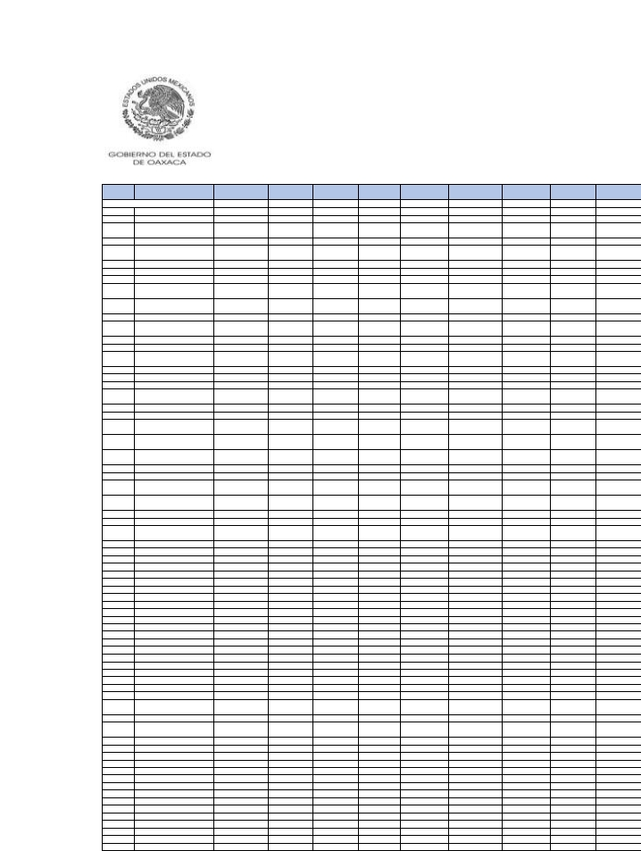Clave
municipio
410
411
412
413
414
415
416
417
418
419
420
421
422
423
424
425
426
427
428
429
430
431
432
433
434
435
436
437
438
439
440
441
442
443
444
445
446
447
448
449
450
451
452
453
454
455
456
457
458
459
460
461
462
463
464
465
466
467
468
469
470
471
472
473
474
475
476
477
478
479

Nombre del municipio
SANTAMARÍAECATEPEC
SANTAMARÍAGUELACÉ
SANTAMARÍAGUIENAGATI
SANTAMARÍAHUATULCO
SANTAMARÍA
HUAZOLOTITLÁN
SANTAMARÍAIPALAPA
SANTAMARÍAIXCATLÁN
SANTAMARÍAJACATEPEC
SANTAMARÍAJALAPADEL
MARQUÉS
SANTAMARÍAJALTIANGUIS
SANTAMARÍALACHIXÍO
SANTAMARÍAMIXTEQUILLA
SANTAMARÍANATIVITAS
SANTAMARÍANDUAYACO
SANTAMARÍAOZOLOTEPEC
SANTAMARÍAPÁPALO
SANTAMARÍAPEÑOLES
SANTAMARÍAPETAPA
SANTAMARÍAQUIEGOLANI
SANTAMARÍASOLA
SANTAMARÍATATALTEPEC
SANTAMARÍATECOMAVACA
SANTAMARÍATEMAXCALAPA
SANTAMARÍA
TEMAXCALTEPEC
SANTAMARÍATEOPOXCO
SANTAMARÍATEPANTLALI
SANTAMARÍATEXCATITLÁN
SANTAMARÍA
TLAHUITOLTEPEC
SANTAMARÍATLALIXTAC
SANTAMARÍATONAMECA
SANTAMARÍATOTOLAPILLA
SANTAMARÍAXADANI
SANTAMARÍAYALINA
SANTAMARÍAYAVESÍA
SANTAMARÍAYOLOTEPEC
SANTAMARÍAYOSOYÚA
SANTAMARÍAYUCUHITI
SANTAMARÍAZACATEPEC
SANTAMARÍAZANIZA
SANTAMARÍAZOQUITLÁN
SANTIAGO AMOLTEPEC
SANTIAGO APOALA
SANTIAGO APÓSTOL
SANTIAGO ASTATA
SANTIAGOATITLÁN
SANTIAGO AYUQUILILLA
SANTIAGO CACALOXTEPEC
SANTIAGO CAMOTLÁN
SANTIAGOCOMALTEPEC
SANTIAGO CHAZUMBA
SANTIAGO CHOÁPAM
SANTIAGODEL RÍO
SANTIAGOHUAJOLOTITLÁN
SANTIAGOHUAUCLILLA
SANTIAGOIHUITLÁNPLUMAS
SANTIAGOIXCUINTEPEC
SANTIAGOIXTAYUTLA
SANTIAGO JAMILTEPEC
SANTIAGO JOCOTEPEC
SANTIAGO JUXTLAHUACA
SANTIAGOLACHIGUIRI
SANTIAGOLALOPA
SANTIAGOLAOLLAGA
SANTIAGOLAXOPA
SANTIAGOLLANOGRANDE
SANTIAGO MATATLÁN
SANTIAGOMILTEPEC
SANTIAGOMINAS
SANTIAGONACALTEPEC
SANTIAGONEJAPILLA

FGP 2021
Monto
2,617,395
1,133,887
3,493,874
141,575,391
6,521,291
3,081,440
1,153,229
6,536,067
7,077,258
1,085,677
1,825,490
5,410,203
1,501,522
1,014,503
2,994,537
2,793,627
5,414,160
8,111,349
1,783,417
1,605,188
940,806
1,370,676
1,443,520
2,133,487
3,301,195
2,611,760
1,263,485
10,219,511
1,767,179
14,278,674
1,380,499
5,162,026
737,223
818,415
967,463
1,658,808
4,583,471
8,811,089
1,767,506
2,563,258
7,877,305
1,476,427
3,659,100
2,574,334
2,219,420
2,315,967
1,554,433
2,575,718
1,866,691
3,671,947
3,606,611
1,160,328
3,520,413
1,058,554
1,010,505
1,488,014
7,235,202
11,276,041
8,083,083
21,003,186
3,146,125
1,131,609
4,888,316
1,486,360
2,227,763
8,032,195
891,290
1,699,404
1,680,260
712,701

FIEPS 2021
Monto
38,104
18,198
40,539
1,377,028
80,646
41,640
19,359
83,783
85,117
17,321
25,999
75,347
19,979
16,555
42,825
35,393
71,419
96,095
27,309
25,137
15,547
19,646
22,525
31,007
42,315
35,208
20,142
105,935
27,967
166,317
21,171
61,572
12,358
12,033
16,013
25,568
57,932
109,114
25,156
35,289
100,697
23,895
49,767
32,398
31,778
31,347
21,888
37,922
23,882
47,319
50,827
17,774
45,171
16,589
16,101
22,164
92,856
134,383
104,787
259,919
42,900
19,235
79,194
22,516
31,052
104,781
14,637
25,697
25,299
12,358

FISAN 2021
Monto
11,474
5,011
14,627
593,653
27,860
13,332
5,133
28,111
30,618
4,798
7,916
23,506
6,467
4,503
13,032
12,030
23,363
34,584
7,838
7,079
4,180
5,963
6,366
9,322
14,105
11,281
5,578
42,293
7,851
60,545
6,056
22,226
3,280
3,549
4,296
7,292
19,781
37,789
7,681
11,177
33,928
6,543
15,772
11,093
9,667
10,008
6,757
11,295
7,894
15,780
15,668
5,071
15,107
4,679
4,490
6,530
31,117
48,081
34,815
89,676
13,617
5,054
21,688
6,528
9,670
34,606
3,973
7,446
7,364
3,193

FOCOISAN 2021
Monto
6,991
3,147
6,331
193,463
13,340
6,844
3,421
14,082
17,119
3,137
4,723
13,702
3,099
2,839
7,237
5,291
11,388
15,465
4,659
4,421
2,675
3,319
3,953
5,185
7,156
5,822
3,519
14,599
5,511
25,207
3,874
10,035
2,215
2,088
2,881
4,421
9,499
16,972
4,178
5,950
15,627
4,143
8,726
4,840
5,481
5,380
3,712
7,026
4,022
7,786
8,633
3,101
7,784
2,840
2,700
3,728
14,779
20,093
16,900
40,747
7,094
3,430
13,792
3,884
5,173
16,836
2,548
4,388
4,360
2,308

FOFIR 2021
Monto
136,453
61,593
163,560
6,509,550
318,667
156,775
63,734
324,824
345,084
58,488
93,162
275,836
75,909
55,715
155,055
140,397
273,578
392,883
95,213
86,236
51,816
70,990
77,535
111,727
162,081
132,232
68,326
463,222
94,896
686,334
72,815
254,596
40,613
42,244
52,950
88,414
229,209
436,227
91,435
132,220
395,368
80,557
183,820
129,470
114,904
117,039
80,057
134,614
89,911
182,781
185,655
61,191
173,875
57,244
55,439
78,801
361,609
550,538
405,359
1,030,653
160,199
63,064
267,435
78,859
114,545
403,695
49,244
89,989
88,773
39,841

FFM 2021
Monto
753,233
629,380
1,078,431
31,138,147
1,918,443
1,314,559
656,950
2,752,081
2,835,335
607,544
574,601
2,258,800
546,473
400,934
2,067,397
1,001,230
887,662
1,828,209
658,848
614,184
542,030
523,200
674,564
577,565
809,422
918,165
523,402
865,711
631,670
29,266,745
950,027
1,692,035
424,450
364,833
465,647
620,870
1,512,152
5,432,564
511,670
753,442
1,021,812
650,662
1,589,404
409,154
557,851
1,108,152
951,544
681,005
767,349
1,704,977
809,597
608,085
1,592,843
485,077
444,393
535,370
992,438
19,350,030
3,429,147
6,760,456
639,000
695,003
2,162,683
689,076
802,112
4,842,903
447,757
782,061
458,882
397,780

FOCO2021
Monto
90,086
20,779
98,883
1,124,179
321,081
139,060
14,141
260,765
337,694
12,717
54,777
117,103
16,000
12,990
114,855
58,621
263,270
470,183
57,636
44,094
10,937
46,673
22,549
82,534
125,052
109,419
30,465
257,053
49,286
745,879
23,374
241,717
6,754
12,116
11,241
43,550
183,104
464,804
69,632
80,998
410,328
28,521
122,670
98,562
86,405
76,489
40,546
89,703
25,907
114,589
147,166
15,923
106,671
14,917
9,976
45,313
445,056
516,821
414,143
1,056,991
137,175
13,167
86,776
33,075
89,181
278,129
10,394
41,463
49,311
5,428

FOGADI2021
Monto
53,190
13,045
60,507
3,727,895
180,094
78,142
8,095
162,748
234,276
9,463
28,687
90,258
21,408
9,488
60,211
59,168
140,711
263,077
29,712
22,716
7,178
26,471
17,255
42,014
68,891
57,599
15,149
206,221
25,405
421,927
14,446
168,897
4,555
8,152
6,749
23,465
120,665
269,262
35,272
57,272
219,904
15,217
65,715
72,521
45,092
45,716
27,204
48,677
19,362
81,403
76,950
9,948
74,590
12,186
11,163
26,887
206,423
336,886
224,880
581,967
75,452
8,504
56,843
22,171
51,152
182,934
8,898
24,457
27,585
3,380

LISRM
Monto
1,023
254
1,411
144,119
3,446
1,479
164
3,431
5,126
219
538
2,170
704
233
1,120
1,767
2,813
5,085
552
422
173
500
403
838
1,374
1,171
281
5,526
476
8,677
305
3,957
95
173
135
438
2,917
5,422
674
1,358
4,681
325
1,320
1,725
838
994
628
931
469
1,857
1,430
233
1,671
326
350
554
3,960
7,258
4,341
11,351
1,402
178
1,192
467
961
4,227
235
507
513
69

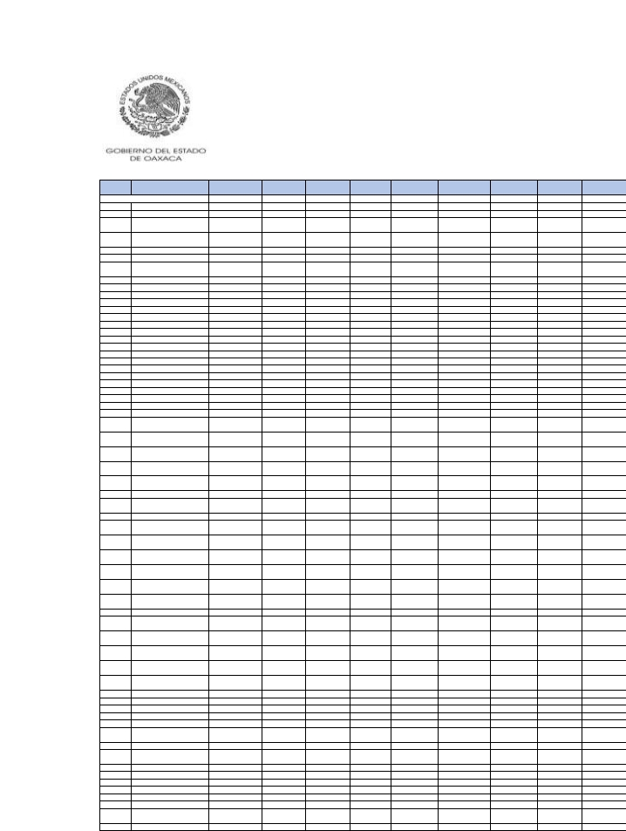Clave
municipio
480
481
482
483
484
485
486
487
488
489
490
491
492
493
494
495
496
497
498
499
500
501
502
503
504
505
506
507
508
509
510
511
512
513
514
515
516
517
518
519
520
521
522
523
524
525
526
527
528
529
530
531
532
533
534
535
536
537
538
539
540
541

Nombre del municipio
SANTIAGONUNDICHE
SANTIAGO NUYOÓ
SANTIAGOPINOTEPA
NACIONAL
SANTIAGO SUCHILQUITONGO
SANTIAGO TAMAZOLA
SANTIAGO TAPEXTLA
VILLATEJÚPAMDE LAUNIÓN
SANTIAGO TENANGO
SANTIAGO TEPETLAPA
SANTIAGO TETEPEC
SANTIAGO TEXCALCINGO
SANTIAGO TEXTITLÁN
SANTIAGO TILANTONGO
SANTIAGO TILLO
SANTIAGO TLAZOYALTEPEC
SANTIAGOXANICA
SANTIAGOXIACUÍ
SANTIAGO YAITEPEC
SANTIAGO YAVEO
SANTIAGOYOLOMÉCATL
SANTIAGO YOSONDÚA
SANTIAGO YUCUYACHI
SANTIAGOZACATEPEC
SANTIAGOZOOCHILA
NUEVOZOQUIÁPAM
SANTODOMINGOINGENIO
SANTODOMINGO
ALBARRADAS
SANTODOMINGOARMENTA
SANTODOMINGOCHIHUITÁN
SANTODOMINGODE
MORELOS
SANTODOMINGOIXCATLÁN
SANTODOMINGONUXAÁ
SANTODOMINGO
OZOLOTEPEC
SANTODOMINGOPETAPA
SANTODOMINGOROAYAGA
SANTODOMINGO
TEHUANTEPEC
SANTODOMINGO
TEOJOMULCO
SANTODOMINGO
TEPUXTEPEC
SANTODOMINGO
TLATAYÁPAM
SANTODOMINGO
TOMALTEPEC
SANTODOMINGOTONALÁ
SANTODOMINGO
TONALTEPEC
SANTODOMINGOXAGACÍA
SANTODOMINGO
YANHUITLÁN
SANTODOMINGOYODOHINO
SANTODOMINGOZANATEPEC
SANTOSREYESNOPALA
SANTOSREYESPÁPALO
SANTOSREYESTEPEJILLO
SANTOSREYESYUCUNÁ
SANTOTOMÁSJALIEZA
SANTOTOMÁSMAZALTEPEC
SANTOTOMÁSOCOTEPEC
SANTOTOMÁSTAMAZULAPAN
SANVICENTE COATLÁN
SANVICENTE LACHIXÍO
SANVICENTE NUÑÚ
SILACAYOÁPAM
SITIODEXITLAPEHUA
SOLEDADETLA
VILLADE TAMAZULÁPAMDEL
PROGRESO
TANETZE DEZARAGOZA

FGP 2021
Monto
1,621,109
2,182,910
48,158,691
5,538,193
3,702,327
2,514,956
2,511,089
2,886,981
857,968
3,555,783
2,379,815
3,018,241
3,351,220
1,090,975
3,309,787
2,418,826
1,508,397
3,105,772
4,650,994
2,439,005
5,425,328
1,223,470
6,752,991
1,582,829
2,026,906
10,350,510
1,063,437
2,449,632
1,417,538
6,176,313
1,207,516
2,625,891
1,246,454
5,079,924
1,461,979
60,902,488
3,523,393
3,274,868
780,085
2,551,624
5,456,707
929,037
1,234,902
2,634,294
892,861
10,648,801
9,224,898
2,427,540
1,590,032
1,556,865
3,312,238
2,044,662
2,827,442
2,228,987
3,123,738
2,856,449
1,008,997
6,057,688
1,219,388
2,933,938
7,055,437
1,572,811

FIEPS 2021
Monto
23,810
29,366
526,291
66,047
46,178
35,549
31,319
25,832
13,956
48,849
32,685
39,039
48,659
15,284
46,693
35,564
21,121
43,085
65,820
28,617
71,687
19,046
75,488
21,158
26,526
107,430
17,243
33,884
18,205
76,151
19,914
36,166
20,294
67,101
23,583
678,883
46,350
43,160
12,212
32,921
70,309
15,746
19,368
31,952
13,973
100,948
112,746
34,011
22,622
24,352
41,560
28,268
38,742
30,618
39,724
37,528
16,552
79,252
19,849
36,503
78,943
22,838

FISAN 2021
Monto
7,096
9,458
202,102
23,520
15,805
10,956
10,796
12,153
3,808
15,382
10,342
13,040
14,647
4,779
14,398
10,578
6,546
13,496
20,284
10,417
23,479
5,400
29,128
6,733
8,696
44,576
4,715
10,639
6,080
26,390
5,353
11,392
5,520
21,937
6,476
260,114
15,173
14,133
3,438
11,029
23,445
4,136
5,442
11,269
3,919
45,263
39,521
10,557
6,953
6,864
14,217
8,896
12,264
9,639
13,431
12,258
4,514
26,020
5,406
12,545
30,115
6,841

FOCOISAN 2021
Monto
3,896
4,591
72,811
10,752
7,481
5,840
4,449
5,532
2,431
8,129
5,260
6,511
8,557
2,385
8,012
5,998
3,573
7,112
11,660
4,794
11,220
3,218
8,476
3,891
4,421
8,535
3,016
5,534
2,820
12,311
3,519
5,909
3,550
10,887
4,070
86,065
7,501
7,867
1,995
5,157
12,057
2,746
3,383
6,211
2,399
19,099
17,188
6,030
3,873
4,165
7,077
4,476
6,333
5,104
6,398
5,933
3,068
13,265
3,428
5,790
12,333
3,931

FOFIR 2021
Monto
85,512
111,660
2,261,263
266,338
181,331
130,601
125,997
116,979
47,041
181,157
122,560
151,689
174,701
57,423
170,527
127,082
77,385
159,950
240,115
117,956
276,231
66,034
339,221
77,016
100,708
519,747
58,022
126,091
70,719
302,513
66,165
134,739
68,083
256,634
79,839
2,982,154
177,007
163,168
42,183
129,089
270,458
51,627
66,291
126,485
47,648
456,076
455,500
124,382
82,838
83,908
163,211
105,843
144,853
113,375
155,661
142,920
55,632
301,649
66,807
144,376
340,049
81,384

FFM 2021
Monto
593,054
697,754
12,245,058
2,035,308
1,524,245
1,362,225
2,732,139
988,987
479,325
835,504
690,484
683,494
1,286,004
439,689
1,196,086
697,214
655,634
1,399,804
1,325,134
943,770
1,742,275
556,467
744,631
569,574
844,399
1,894,692
509,339
1,113,186
385,501
2,273,794
425,395
1,133,263
535,210
966,245
665,974
17,993,189
1,093,157
690,698
427,179
1,076,089
2,930,320
470,189
492,936
847,493
423,021
3,126,051
2,903,426
1,244,676
604,340
577,486
1,336,208
676,783
1,349,078
1,031,232
857,439
662,906
486,606
2,381,807
671,905
1,267,194
2,656,438
706,989

FOCO2021
Monto
25,542
56,842
1,440,257
263,862
119,435
97,787
66,147
53,464
3,020
141,541
90,710
122,598
87,849
13,554
144,371
96,124
42,860
136,100
209,571
51,834
232,093
25,482
166,781
10,075
45,724
197,494
20,838
100,286
37,462
333,936
18,564
92,306
25,156
249,818
31,732
1,651,908
147,429
153,415
3,472
78,593
188,062
6,908
29,821
39,304
8,174
323,815
502,032
75,830
29,149
45,418
102,050
67,823
109,947
58,583
120,138
88,531
11,006
178,823
18,658
137,457
189,626
44,238

FOGADI2021
Monto
22,577
42,751
1,174,864
160,556
80,313
54,244
60,054
49,389
5,802
78,267
55,058
79,445
55,501
19,681
72,012
47,887
29,070
71,803
106,322
56,228
145,366
17,243
215,282
10,036
34,263
383,710
11,928
57,222
29,984
173,523
10,278
55,605
13,435
141,606
17,252
1,834,345
84,360
77,007
6,389
63,389
122,166
4,963
16,035
45,572
6,629
264,750
291,793
45,509
25,754
22,393
74,063
47,398
63,601
39,558
75,496
55,332
10,386
119,489
12,207
86,339
200,109
25,114

LISRM
Monto
643
1,157
30,597
2,983
1,856
1,124
1,684
1,378
208
1,482
1,202
1,759
1,275
653
1,338
890
596
1,448
1,975
1,638
3,115
389
7,348
281
853
13,586
228
1,153
731
3,414
196
1,215
250
2,636
358
54,788
1,709
1,496
226
1,605
2,648
125
301
1,401
167
6,824
5,923
978
741
443
1,827
1,048
1,340
899
1,772
1,266
292
2,695
273
1,604
5,726
468

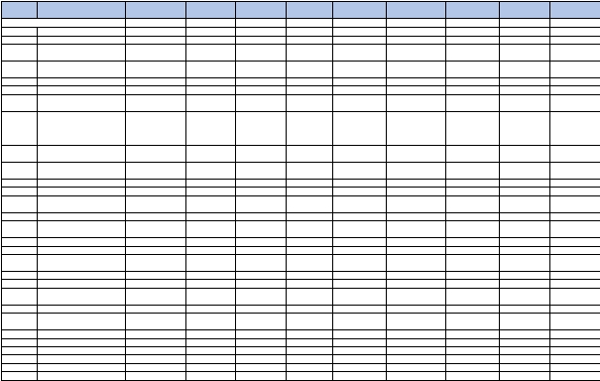Clave
municipio
Nombre del municipio
FGP 2021
Monto
FIEPS 2021
Monto
FISAN 2021
Monto
FOCOISAN 2021
Monto
FOFIR 2021
Monto
FFM 2021
Monto
FOCO2021
Monto
FOGADI2021
Monto
LISRM
Monto

542
543
544
545
546
547
548
TANICHE
TATALTEPECDE VALDÉS
TEOCOCUILCODE MARCOS
PÉREZ
TEOTITLÁNDE FLORESMAGÓN
TEOTITLÁNDELVALLE
TEOTONGO
TEPELMEME VILLADE
MORELOS
1,281,492
3,640,262
1,692,026
10,443,460
4,070,858
1,612,848
2,478,186
20,432
48,734
22,555
144,996
53,202
22,476
32,378
5,663
15,790
7,325
45,400
17,686
7,001
10,672
3,512
8,213
3,450
22,580
9,741
3,561
7,147
69,450
185,200
86,465
541,156
205,002
83,343
119,971
700,676
1,479,185
660,145
4,801,356
1,679,250
661,549
1,109,871
23,407
175,493
27,787
243,101
161,802
24,526
45,800
14,172
96,931
30,669
206,017
107,250
25,165
33,819
299
1,957
941
5,153
2,437
735
851

HEROICAVILLATEZOATLÁNDE

549
SEGURAYLUNA,CUNADELA
8,298,644
109,407
35,547
18,145
412,229
3,218,158
307,163
170,393
3,165

INDEPENDENCIADE OAXACA

550
551
552
553
554
555
556
557
558
559
560
561
562
563
564
565
566
567
568
569
570
SANJERÓNIMO
TLACOCHAHUAYA
TLACOLULADE MATAMOROS
TLACOTEPECPLUMAS
TLALIXTACDE CABRERA
TOTONTEPECVILLADE
MORELOS
TRINIDADZAACHILA
LATRINIDADVISTAHERMOSA
UNIÓNHIDALGO
VALERIOTRUJANO
SANJUANBAUTISTAVALLE
NACIONAL
VILLADÍAZ ORDAZ
YAXE
MAGDALENAYODOCONODE
PORFIRIODÍAZ
YOGANA
YUTANDUCHI DE GUERRERO
VILLADEZAACHILA
SANMATEOYUCUTINDOO
ZAPOTITLÁNLAGUNAS
ZAPOTITLÁNPALMAS
SANTAINÉSDE ZARAGOZA
ZIMATLÁNDE ÁLVAREZ
5,433,048
25,516,278
861,825
14,314,344
4,178,369
2,188,328
848,282
12,517,243
1,234,366
13,564,901
5,858,133
4,240,248
1,634,826
1,414,387
1,808,315
32,577,107
2,520,345
2,617,483
1,440,954
1,726,666
15,469,911
61,012
253,811
13,414
145,366
54,150
30,184
14,507
152,714
18,350
169,633
71,146
65,395
22,044
22,154
25,317
329,789
35,611
36,524
20,352
25,683
173,823
22,932
107,225
3,811
60,502
17,916
9,496
3,806
53,862
5,403
58,409
25,251
18,626
7,069
6,241
7,758
136,606
10,920
11,400
6,262
7,552
65,894
10,500
36,333
2,619
20,656
9,963
4,880
2,646
27,594
3,157
26,228
11,271
11,209
3,801
3,890
4,539
42,435
5,994
6,080
3,375
4,432
28,200
254,390
1,174,980
45,892
671,250
205,070
112,481
47,554
612,939
64,870
677,997
291,227
226,085
82,626
76,051
90,366
1,514,442
129,296
135,390
74,451
90,656
734,647
1,296,663
8,434,005
694,710
3,463,883
1,399,227
918,258
509,093
6,687,281
384,005
4,851,606
2,055,243
2,223,454
782,819
567,493
704,692
11,464,655
675,063
919,550
822,159
799,455
5,191,043
148,681
561,775
11,752
250,355
156,313
82,024
6,919
372,207
38,125
610,046
188,290
82,742
40,735
38,798
32,756
1,129,868
89,503
97,823
39,126
45,070
526,362
121,186
697,848
9,314
393,386
86,162
50,319
6,164
322,458
21,216
405,490
159,757
49,938
30,746
19,984
17,435
1,002,726
46,681
56,890
26,175
26,638
423,200
3,153
21,626
236
13,147
1,684
1,021
168
8,107
395
8,894
4,383
1,098
738
383
324
26,910
872
1,264
587
537
10,752

